

**Department of Computing**

**Te Horo Rorohiko**

**CH3880 Bachelor of Information and Communications Technology**

**BCCE301 Cooperative Education Project**

**Semester 2, 2017**

**<Online Quiz project**

**Ara Institute of Canterbury>**

**FINAL REPORT**

<Daming Zhang>

<99137058>

Table of Contents

2 Introduction Document 1

3 Executive Summary 2

4 Background 3

5 Expected outcomes 3

5.1 Industry Outcomes 3

5.2 Academic Outcomes 3

5.3 Personal Outcomes 4

6 Progress Made 4

6.1 Overview of objectives 4

6.2 Milestones achieved 5

6.3 Problems encountered 6

7 Course Management 7

8 Review of previous courses 7

8.1 SOFTWARE Engineering 1 7

8.2 IS206 BEST JAVA Practice 8

8.3 IS202 WEBSITE Design 8

8.4 PR203 Database Management Systems 8

8.5 PR280 Software Engineering 2 8

8.6 IS301 Management of ICT 8

8.7 Recommendations 8

9 Risk Management 8

10 Quality Assurance 10

11 Methodologies 10

12 Appendices 11

13 References 12

# Introduction Document

Online quiz Project – Halfway Report – Iteration 01

The final report is about 30 pages

This document gives the summary of what I have achieved in the project. I will cover these aspects:

* the explanation of the project and its background
* how it was planned and implemented
* the achievements of the project
* how the project was managed using Scrum
* evaluation of QA programs and risk management programs

I will conclude this report with the methodology essay summary, agile for software management.

# Executive Summary

Anne Wignall is a retired teacher of science and chemistry. She is also a textbook author. In recent few years, Anne has devoted herself to create a number of computer activities to help student to study on Moodle. Anne wishes to perfect Diagram quiz and Hangman exercise.

My mission is to fix the quizzes, translate them from Flash/Actionscript into html5/ES6 and work on Moodle 3. The project also needs to be supported by smart phone and tablet (Android&IOS).

The tasks are:

* Diagram:
  + Dragging the correct keyword answer label into the appropriate box, the positions of the boxes display random coordinates each time.
  + Input the right answer into the appropriate boxes the position of the boxes display random coordinates each time.
  + Dragging the correct image answer label into the appropriate box, the positions of the boxes displayed base on the XML file.
  + All the types of Diagram needs to display score base on the how well users answer the quiz.
* Hangman: Filling the blanks of missing words of a definition and show the process of getting the all of the words right. Record the letters that are not in the answer. It also needs to record the score. The answers and question are created base on the XML file.

The following document serves as a summary of my experiences so far, while undertaking my industry project for the BCCE301 Co-operative Education Project at CPIT.

Once complete, write a summary of the document.

2nd 1/2

# Background

Anne Wignall is a retired teacher of science and chemistry. She is also a textbook author. In recent few years, Anne has devoted herself to create a number of computer activities to help student to study on Moodle. Anne wishes to perfect Diagram quiz and Hangman exercise.

Anne uses a quiz tool called Hot Potatoes to create quizzes in HTML and JavaScript. The plugin Hot Potatoes, allows quizzes to be run on Moodle. The version of Moodle on Anne’s PC is Moodle2. The schools she works with are using Moodle 3 now, which is part of the reason that need to upgrade the files to the demanding environment of Moodle3. The currently issues are:

Diagram:

1. It can not to be set as an activity on the Moodle now. It cannot get mark from Moodle.
2. Each time that the diagram generated has different coordinate of answer boxes, The boxes always keep in the same position in the diagram at the moment, so when users do the diagram quiz they may just remember the order of the answer not really know the answer match what part in the picture.

Hangman:

1. It has not to be set as an activity on the Moodle now. It cannot get mark from Moodle.
2. Anne wants students to fill in a whole sentence or a short paragraph by guessing letters until they can determine the missing words. Also the Hangman needs a sort of count number to calculate how many times users can get wrong guessing letters. Some sort of gamification such as an animation that includes bombs, explosions or crashes when letters are wrong is desirable but not essential .

# Expected outcomes

## Industry Outcomes

The project brought about the following outcomes.

* All resources are fixed and have features mentioned above
* Testing results
* Defect tracking
* Documentation of the quiz resources (what is fixed, usage)
* Resources released in the form of Moodle backup

## Academic Outcomes

* Project proposal
* Halfway report
* Academic / Industry supervisor assessments
* Methodology essay
* Final report including
  + Risk management program
  + Quality assurance program
  + Review of 200 and 300 level courses
* Poster
* Panel

## Personal Outcomes

I gained the following skills and knowledge that has not been a core component of any courses I have studied at Ara.

* Web technology
* Deeper understanding of JavaScript
* Design Patterns for efficiency and effectiveness
* GitHub for version control
* Moodle as the programs work on Moodle
* jQuery to support multi-platform
* Scrum for project management

## Comparison of Initial and Actual Outcomes

# Progress Made

## Overview of objectives

Risk management documentation, including continuous identification and contingency planning.

Quality assurance measures documented.

Mid project report summarizing how the project is progressing. Adjustments to the project made as required.

Final presentation summarizing the project.

Documentation of current web application where applicable.

Sign-off Proposal

BurnDown chart see appendix ??

DailyPlan sheets

Weekly Report

Methodology topic

Diagram project class diagram

Diagram project code

Diagram function check list by client

Diagram work check by client

Notes for Risks and XP game for Methodology topic

Animation idea for "Hangman" project

A "Hangman" demo with basic function code

CoordianteCreater

CoordianteCreater2

QA plan draft

Diagram project demo on web page

CoordinateCreater demo on web page

## Milestones achieved

**Research of Dirgram and related issues**

* Ensured that the project was actually feasible.
* Achieved understanding of the required functionality.
* Gained understanding of some common issues.

**Risk Management Plan**

* 50 risks identified in notes.
* 8 main risks’ details documented for top 5 risks. Including:

impact, possibility and contingency plans

**Quality Assurance Plan**

* QA for course: Task list created to ensure the project meets or exceeds the required quality.
* QA for industry: Metrics defined for determining the success of the final product.

**Diagram project**

* Get knowledge of using JsDoc3 to automatically generate API.
* Tackled some major issues early.
* Used to refine project requirements.

**Diagram project functional**

* Diagram project created. Including two types of quiz: drag and input.
* Tested functionality on Chrome, Firefox, Safari browsers.
* Tested responsive design on Iphone6 and Android

**Diagram coordinate generator tool**

* The coordinate generator tool created.
* Tested functionality on Chrome, Firefox, Safari browsers.

**Hangman project**

* Gain experience of Javascript event binding

**Management of CE301 Course**

* Implemented basic function, on progress
* Proposal: After meeting with client Anne, I took two days to get a proposal draft, after that I show it to my industry supervisor, academic supervisor and client, got feedback from them. Then modified it. I got it sign off by client on 6th Sep.
* Daily Plan: I meet with my industry supervisor Mike on Monday every week to show him my plan of the whole week, write detail work for each hour. I study about 6 hours on this course from Monday to Friday.
* Weekly report: I get feedback from the weekly meeting with Phillip and Mike, they give me suggestions and track my process every time to lead the course work can be finish in an appropriate pattern.
* Methodology Essay: My methodology essay topic is “Agile Project Management” I have written the part A of my methodology essay base on what I have meet with my client during the development period for the first 6 weeks.
* Halfway report: Before I finish the Halfway report, I prepare a list of deliverable and document for proving what I have done during halfway time.

## Problems encountered

Software management

* Constantly changed requirements
* Features added
* API for maintenance

Evolving requirements

* Added JavaScript tasks

Lack of development experience

* Research required while developing HTML5 animation

# Course Management

**Time Management**

* Myhours track time log
* Plan the work for next week in detail

**Choice of BCRP203 DataBase class to accompany project**

* Have not been able to apply gathered knowledge to project.
* Android development crossovers.
* Goals and objectives post CPIT.

**Compromises in other aspects of life**

* Prioritizing:

Online Quiz Project>CE301>PR203 >Exercise>Relaxation/Sanity> Social Life

**Daily diary, weekly reports and progress meetings**

* Do daily plans for next week on every Monday after meeting client.
* Talk about where I’m at of the project. Major issues and successes with Dr. Mike and Dr. Luofeng.
* Check and discuss academic work with Phillip at least once a week

Effectiveness

Reflection

# Review of previous courses

## SOFTWARE Engineering 1

This was a course that I strongly recommended to any prospective developer at CPIT. It has created an entirely new frame of thought and perspective from which I now view projects. While we did encounter various levels of testing in other courses, it was never structured. It relied heavily on the intuition of the developer, and had very little emphasis on test planning. This type of testing may provide sufficient results for experienced developers, who know precisely where to look to find defects. These hunches are based on past experience. They are often drawn to problematic functionality, which have caused grief in the past. Being a relatively inexperienced student, an adequate testing phase is required to gain a tangible benefit from testing.

Test planning is arguably the most important phase of testing. It ensures that the test cases cover the most crucial aspects of the software as possible. The testing time frame is usually restrictive. It represents a major development cost, and through the eyes of many produces less tangible benefits than other project phases.

The course proved that the benefits of testing are in fact very tangible. The relationship between effective testing and quality assurance was made apparent throughout the course. A product which is released with quirks, bugs or unintentional behaviour can reduce confidence in the development brand and image. On the other hand a quality product that has undergone effective testing can induce an image of professionalism.

Mention Mehdi input: Metrics, importance of structure and frameworks. QA and testing interrelated.

**Recommendations**

## IS206 BEST JAVA Practice

**Recommendations**

## IS202 WEBSITE Design

**Recommendations**

## PR203 Database Management Systems

**Recommendations**

## CE301 Cooperative Education Project

**Recommendations**

## PR280 Software Engineering 2

JavaScript knowledge

Freedom of own project

Mike Lance hands-on learning approach

Use of JavaScript in FormTab application

**Recommendations**

## IS301 Management of ICT

Looking at the bigger picture in ICT

Evaluating potential solutions or options

Creating criteria for evaluation

## Recommendations

# Risk Management

Risks in the software developing can not be avoid, many reason can slow down the project or even make the project fail. There are three parts of risk needs to consider.

| **Risk name** | **Impact** | **Possibility** | **Exposure** | | **Mitigation** | **Contingency** |
| --- | --- | --- | --- | --- | --- | --- |
| **Member not familiar with the technology** | 80% | 80% | 64% | Schedule time for learning and researching | | To get support and helps from Academic and Industry Supervisor |
| **Requirements change or be added** | 60% | 70% | 42% | Check with the client’s priority. Then modify the plan of project | | Change project plan and take changes into the next weekly plan |
| **Testing environment not available** | 80% | 20% | 16% | Check available environment | | Build environment |
| **Too many bugs that not all can be fixed** | 80% | 20% | 16% | N/A | | Change project scope to fix only those of high priority |
| **Member sick** | 80% | 10% | 8% | Do not work day and night, having rest is important | | Have enough rest every day. |
| **Client is not available** | 30% | 20% | 6% | Get the client’s schedule beforehand | | Make plan to do things that I can do without the client |
| **Data lost** | 90% | 5% | 4.5% | Using GitHub and One Drive to manage the version control | | Download from repository  Or One Drive |
| **Budget might be needed** | 50% | 1% | 0.5% | Check if I can use budget and how much | | Select methods that do not need money |

1. Project Risk – some factors could cause a project to fail;

1.1 Financial - the investment of the project is not enough;

1.2 Strategic – the requirement may change or need to add some new feature;

1.3 Technical – the key technology of the project may not get enough support in the future;

1. Production System Risk
   1. The production support team members may have not enough experience and skills sometimes.
2. Personal Risk

3.1 The degree or the knowledge of skill may not enough to support the project.;

3.2 The impact on developers health and the emotional will effect the project schedule;

Effectiveness

Reflection

# Quality Assurance

Quality Assurance is short for QA, which means the approaches of checking if a project meets the client’s requirements.

1. Readability by maintainer: In order to making easier for maintainer, write readable comments and modularity code help maintainer understand the system quickly.
   1. Comments: It includes function header comments and line comments. Describe what happens for the code.
   2. Modularity: Make the code structural and clear, can be easy to add up new function or reuse the code for maintainers.
2. Separate js file: Separate the js file into different file base on the class and design pattern
3. Classes: Create classes base on the
4. XML structure: The XML should be structural, it should not write every tag in one line. It needs to

use indentation for each child tag.

1. Functionality: The project should work as required, which means the project works. There are three main users that will use the project and care about the functionality.
   1. Client
   2. 3rd World students on mobile devices
   3. Teachers- create new quizzes by modify xml file

Effectiveness

Reflection

# 

# Methodologies

For this part, my methodology essay topic is “Agile software management”. Agile management of IT project is widely used for software development. Extreme Programing as a common agile method, it was first used in the mid 1990’s. It is successful method because it leads customer to fell satisfied. It is not easy to deliver everything that as developers planed forego on some date very far in the future. With using this method, the process delivers the achievement as you plan it. Extreme Programming makes developers to respond confidently to changing requirements or adapting to client feedback.

The XP planning game emphasizes teamwork. Clients, managers, and developers are all equal important role in the collaborative team. It implements a simple and effective environment that encourages and enables developing teams to become highly productive. During the programming period, I met my client Anne one a week. Every time after meeting the requirements changed or were added. It is quite normal happened in the industry. So a good strategy of effectively and clearly communication skill to negotiate with client is very important for managing the project.

# Main Areas of Learning

# Evidence for Assessment Achievements

PRODUCT

Screen shots - storyboard

Code snippets

**COURSE MANAGEMENT**

* established - course proposal signed off on 11 Sept 2017
* actively maintained
* extensive
* exceptionally effective
* displaying excellent control
* initiating communication throughout its execution.

**THE PROJECT**

* completed the project
* to the industry supervisor’s satisfaction
* demonstrating an exceptional grasp of the subject.

**CONTENT OF THE LEVEL 200 AND 300 COURSES**

* correctly identified - all 6 courses are included
* evaluated content – see pages 13-16
* shows material has been applied in a relevant and innovative manner – see recommendation paragraphs on pages 13-16
* perceptive content recommendations

**QUALITY ASSURANCE PROGRAMME**

* created
* maintained
* applied
* comprehensive
* in-depth understanding
* critically analysed
* insightful conclusions

**RISK MANAGEMENT PROGRAMME**

* created
* maintained
* applied
* comprehensive
* in-depth understanding
* critically analysed
* insightful conclusions

**METHODOLOGIES ESSAY/REPORT**

* extensively referenced accepted theory
* industrial practice
* related
* exceptional standard.

**REPORT**

* polished
* imaginative
* clearly and fluent
* insightful
* accurate grammar and spelling.
* very full analysis of performance

**PANEL**

* confident
* skilled communicator
* presented clearly and logically
* responded clearly and logically
* perception in appropriately responding to supervisors’ reports and questions.

**POSTER**

* Imaginatively
* professionally
* displays project’s outcomes
* conveys learning achieved.

# Appendices

Weekly Report

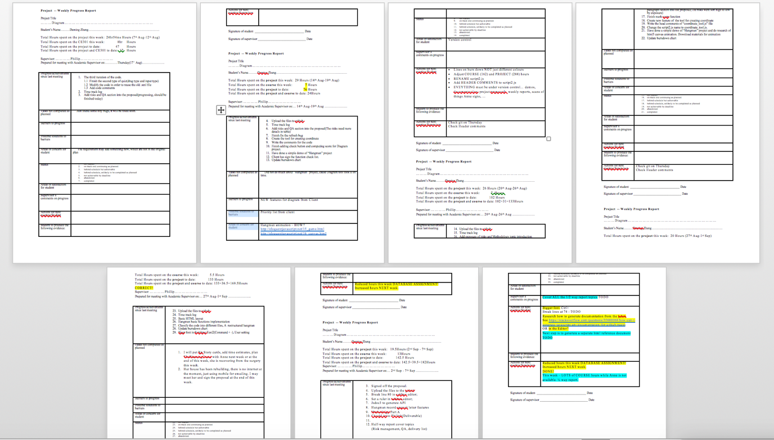

# References